Fabric Calculation Sheet Explanation
We use an Excel worksheet to efficiently process orders by converting raw window measurements into optimized groups for cutting fabric into roller blinds.
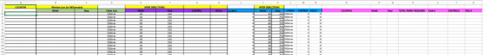This is the fabric calculation section of the sheet, designed to accommodate an
unlimited number of blinds for each job. To build an effective inventory management system for the website, it’s crucial to understand how we calculate the fabric needed for each order. This ensures the system can accurately allocate the required fabric, update stock levels in real time, and determine how much additional stock is needed to prevent shortages. By doing so, we can avoid delays in fulfilling future orders.
We receive blinds orders in the following form as an example.
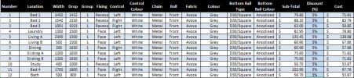This is our order sheet. We receive orders in this format.

These four columns show the blind number, the name or location
of the blind, and the width and drop of the window. These are the
raw measurements provided to us.
These five columns display the selected fabric group. By referring
to the price lists, you can see how the fabric group determines
the cost of the blind. The fixing type either recess or face
indicates whether the blind will be mounted inside the window
frame or on its surface. The control position, left or right, is
important as it specifies the side where the customer wants the
chain. Additionally, we o2er several colour options for control
mechanisms and chain colours.
These columns display the selected options. The fabric
column indicates the texture chosen by the customer,
while the colour column specifies the selected shade
within that texture. We o2er two types of bottom bars: oval
and D30/square. The final column shows the chosen
colour for the bottom bar.
The subtotal represents the total cost per blind before any
discounts are applied. The cost column reflects the final price per
blind after any applicable discounts. The discount column is useful for applying promotions or coupon codes. The final price is then
calculated at the bottom, both with and without GST
The information in this order is implemented into the fabric calculation sheet I had shown from earlier.
The details are entered into the sheet as shown below.
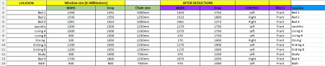The chain sizes are automatically calculated by Excel. In the 'After Deductions' section, the sheet automatically subtracts 30mm from all widths and adds 250mm to all drops, as these adjustments are necessary for the blinds to properly fit the windows. These
deductions account for the raw window measurements provided. Control side and roll preferences are entered manually.
Once the deductions are made, the required fabric is calculated, and nest groups are formed. Fabric rolls are typically 3 meters wide and come in lengths of either 20 or 30 meters. Blinds must be cut in a single direction due to the texture of the material..
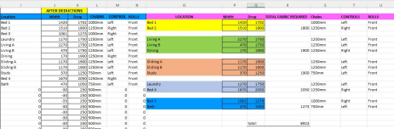After the deductions, the values are sorted and grouped as shown under the pink band. The nest groups represent the most e2icient way to cut the fabric, minimizing waste. Since the width of a fabric roll is 3000mm, the total width of each nest group must not exceed this limit. However, we aim to get as close to 3000mm as possible to minimize wastage, as any leftover fabric from the width is discarded. The largest drop in the nest group is cut first, and this is reflected in the 'Total Fabric Required' column. This column is then summed at the bottom, giving us the total fabric required for the job. In this example, 8923mm, or 9 meters, of fabric from a 3-meter-wide roll is needed to complete the job.
Our inventory management system should be able to calculate how much fabric is required for each customer order and allocate that fabric from our inventory. If there isn’t enough fabric available, we must be notified immediately. After the job is completed, the amount of fabric used, for example 9 meters in the above example should be subtracted from the inventory so that we can accurately track the remaining stock for future jobs.
If you view the tabs in the excel document you will also see how the chain sizes are calculated according to the drop of the blinds.

